**Laporan 6 – Analisa Time Series**

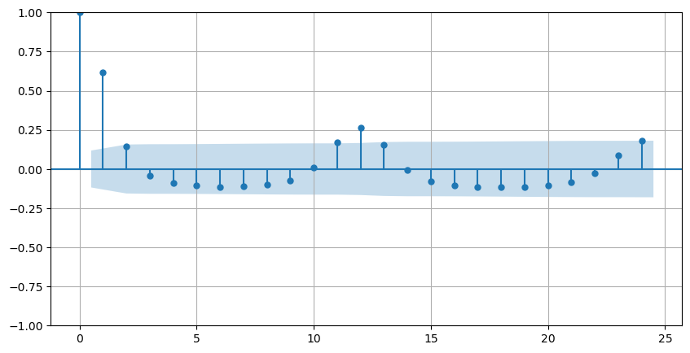

Gambar 1. Grafik ACF hotspot sumatera selatan 2001 - 2023

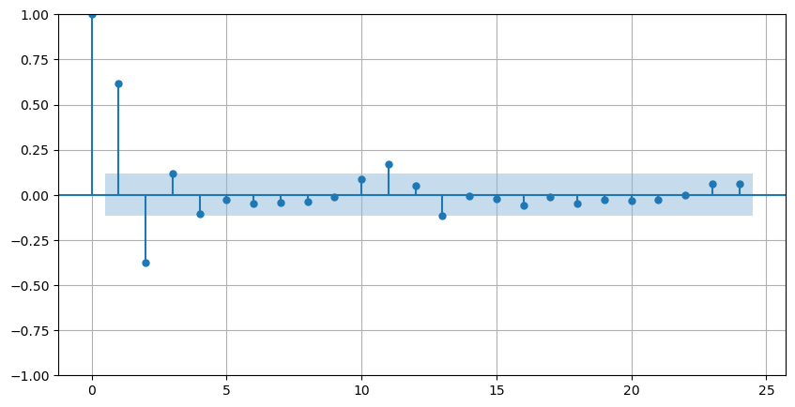

Gambar 2. Grafik PACF hotspot sumatera selatan 2001 – 2023

|  |  |  |  |  |  |
| --- | --- | --- | --- | --- | --- |
| **Metode** | ***Lags*** | ***P-value*** | ***Critical values*** | | |
| **1%** | **5%** | **10%** |
| ADF | 15 | 0,002 | -3,46 | -2,87 | -257 |
| PP | 15 | 0,000 | -3,46 | -2,87 | -257 |
| KPSS | 15 | 7,999 | 0,74 | 0,46 | 0,35 |